**WEEK-2**

**PLSQL_EXERCISES**

**EXERCISE 1: CONTROL STRUCTURES**

**ControlStructures.sql**

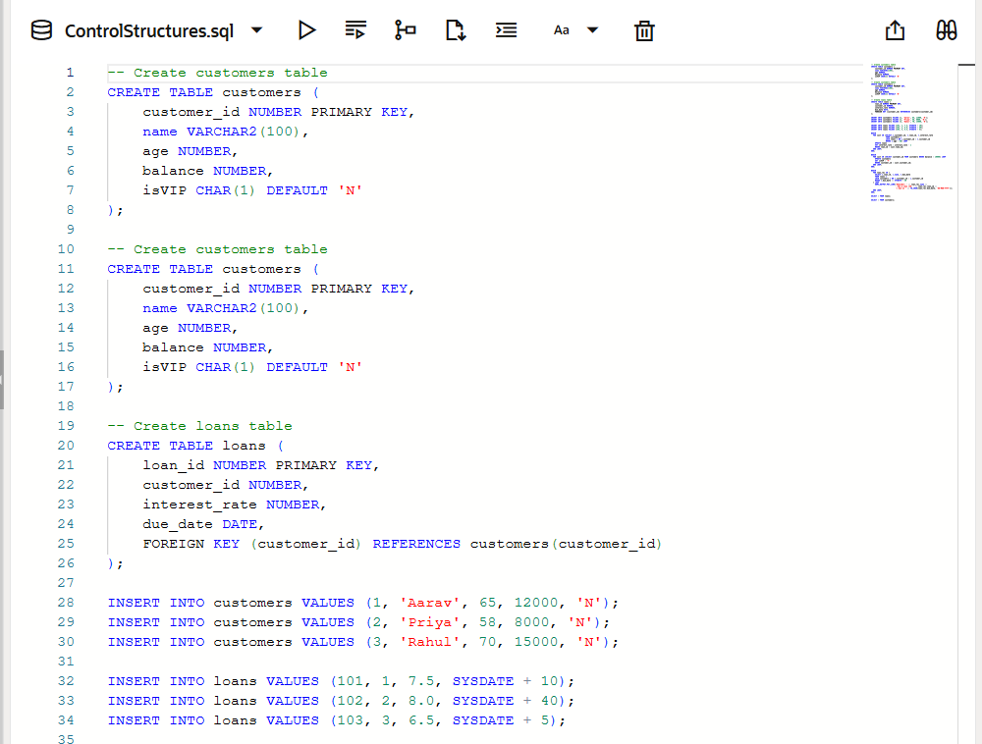

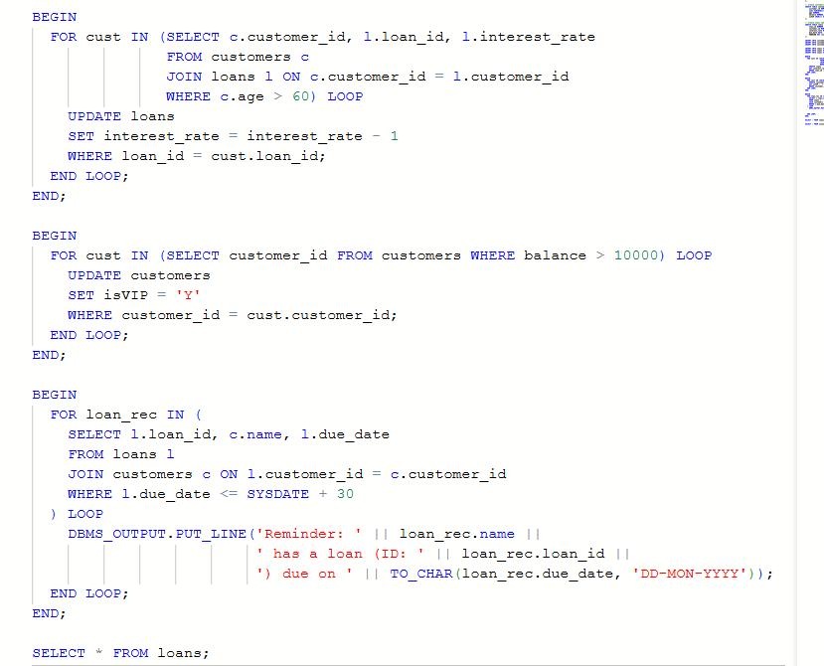

**Output:**

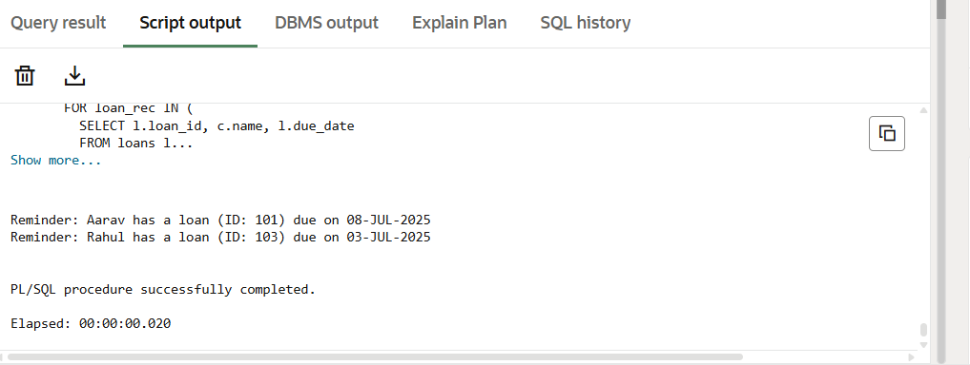

**EXERCISE 3: STORED PROCEDURES**

**StoredProcesures.sql**

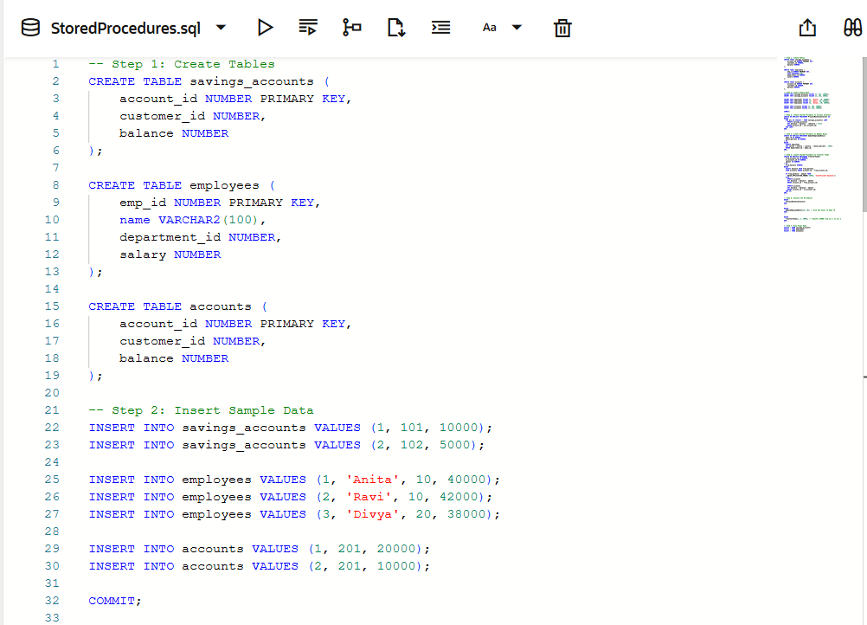

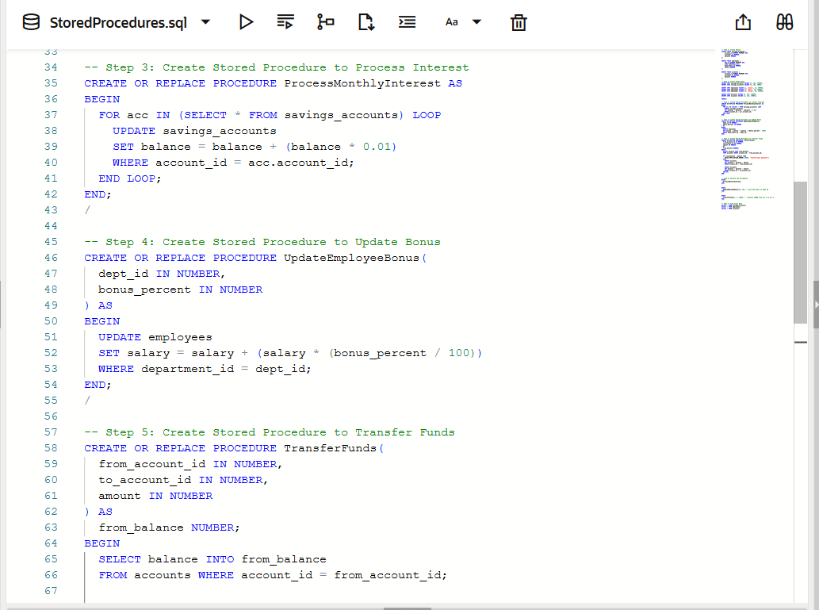

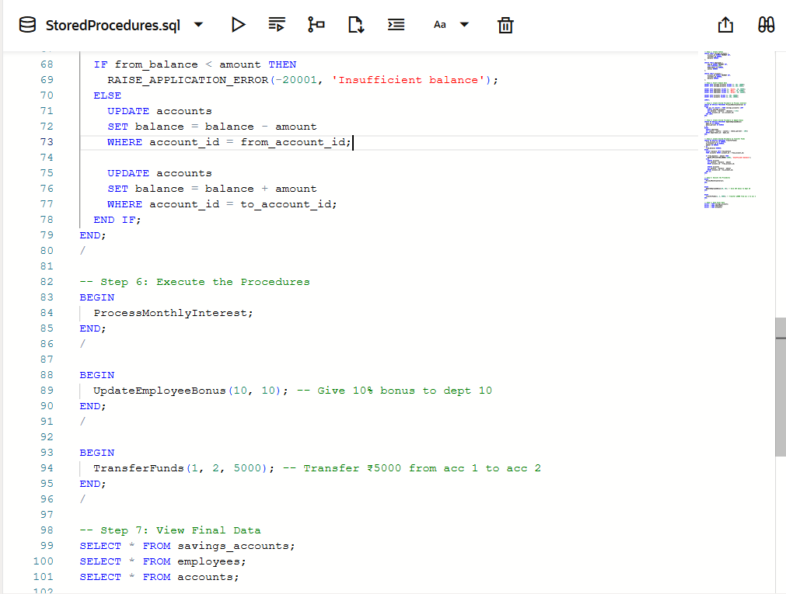

**Output:**

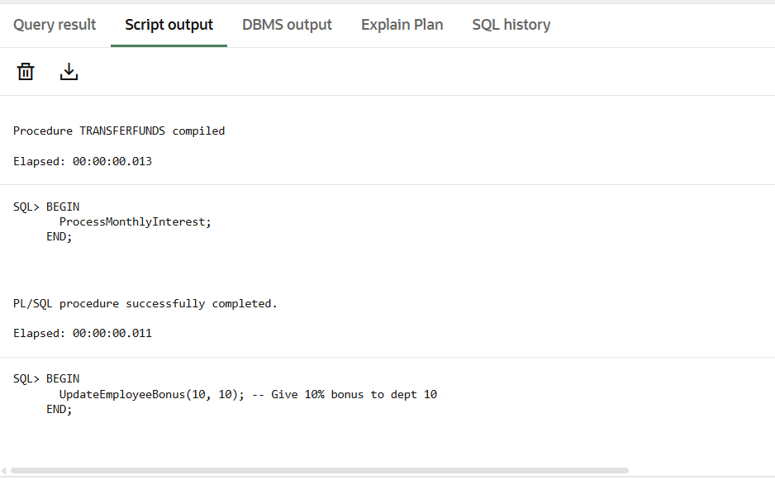

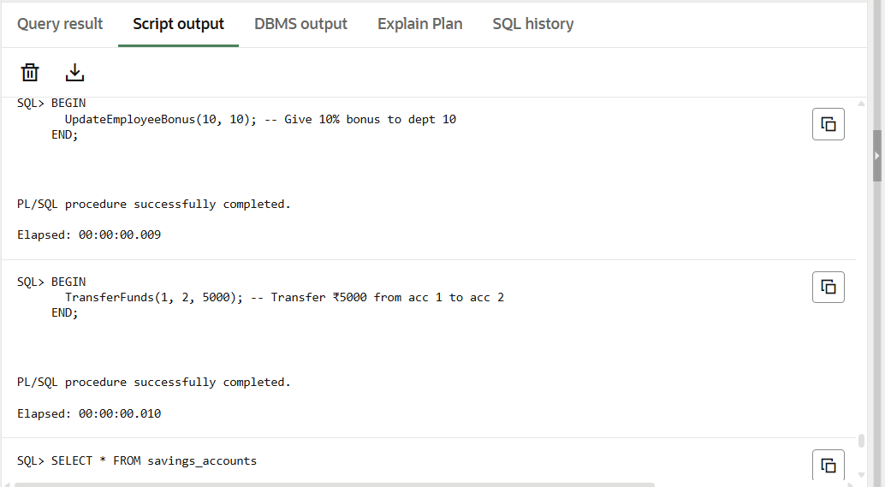

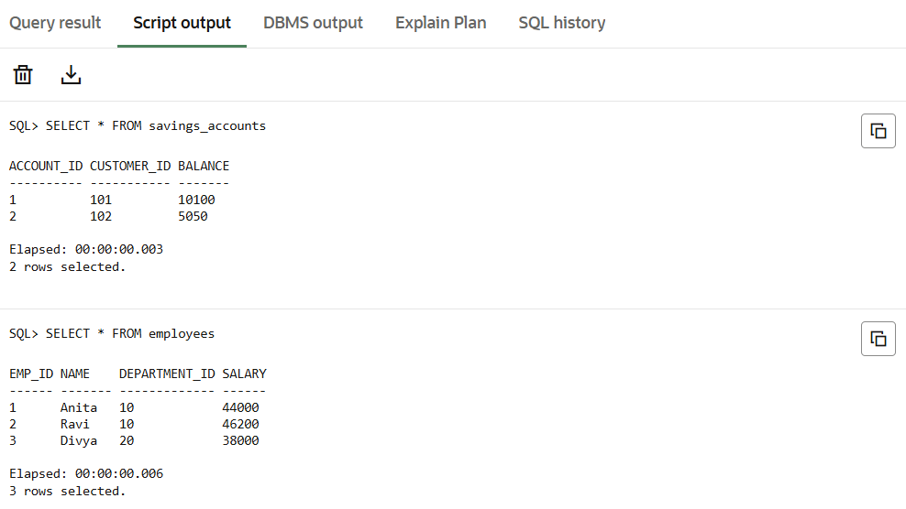

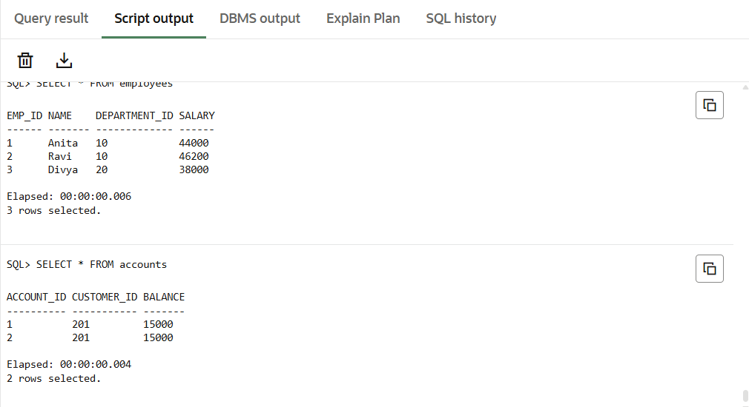

**JUNIT_BASIC TESTING EXERCISES**

**EXERCISE 1: SETTING UP JUNIT**

**Pom.xml:**

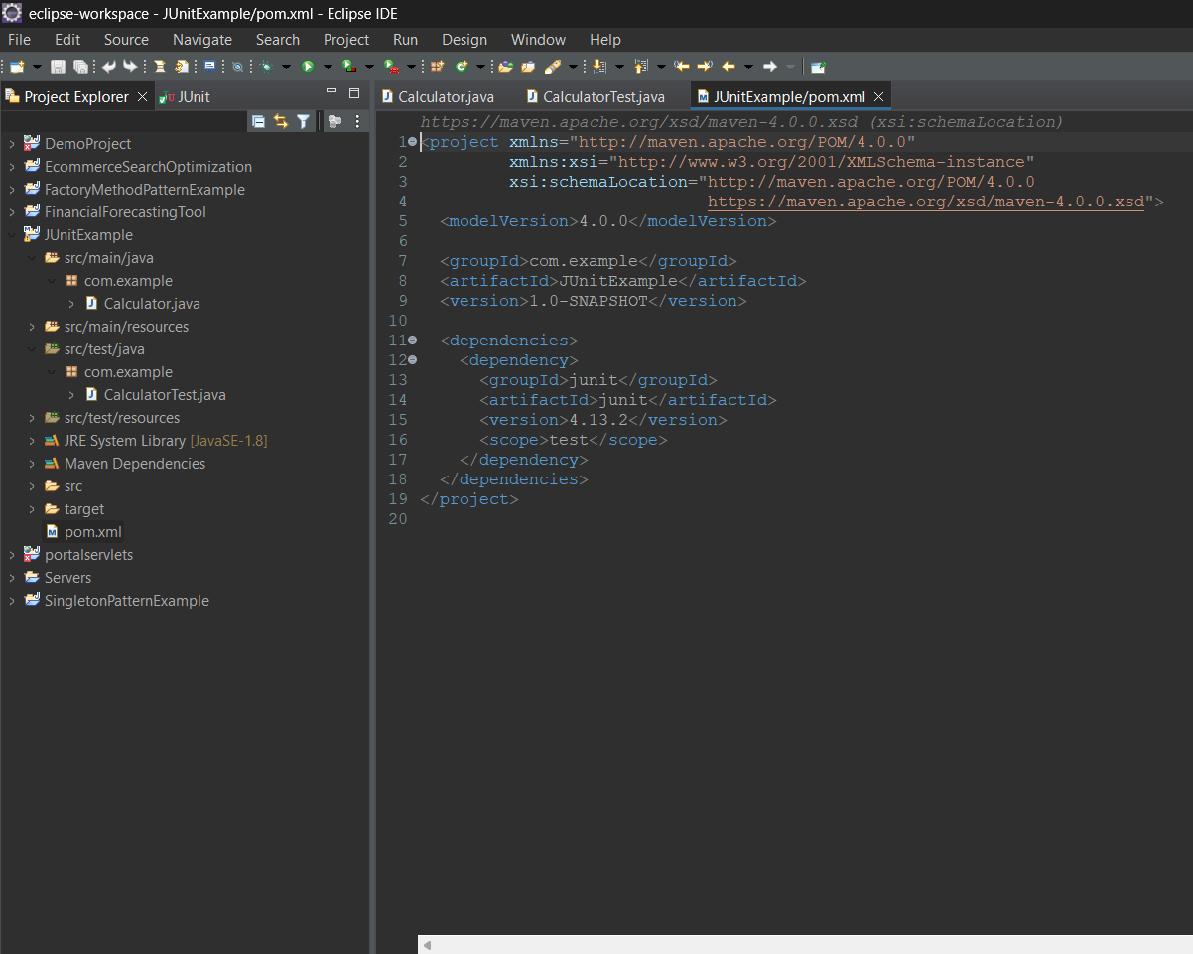

**Calculator.java:**

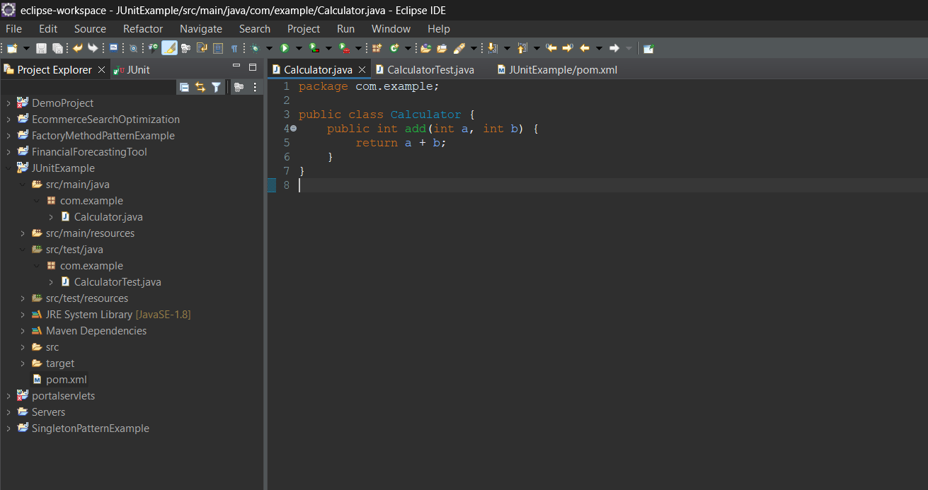

**CalculatorTest.java:**

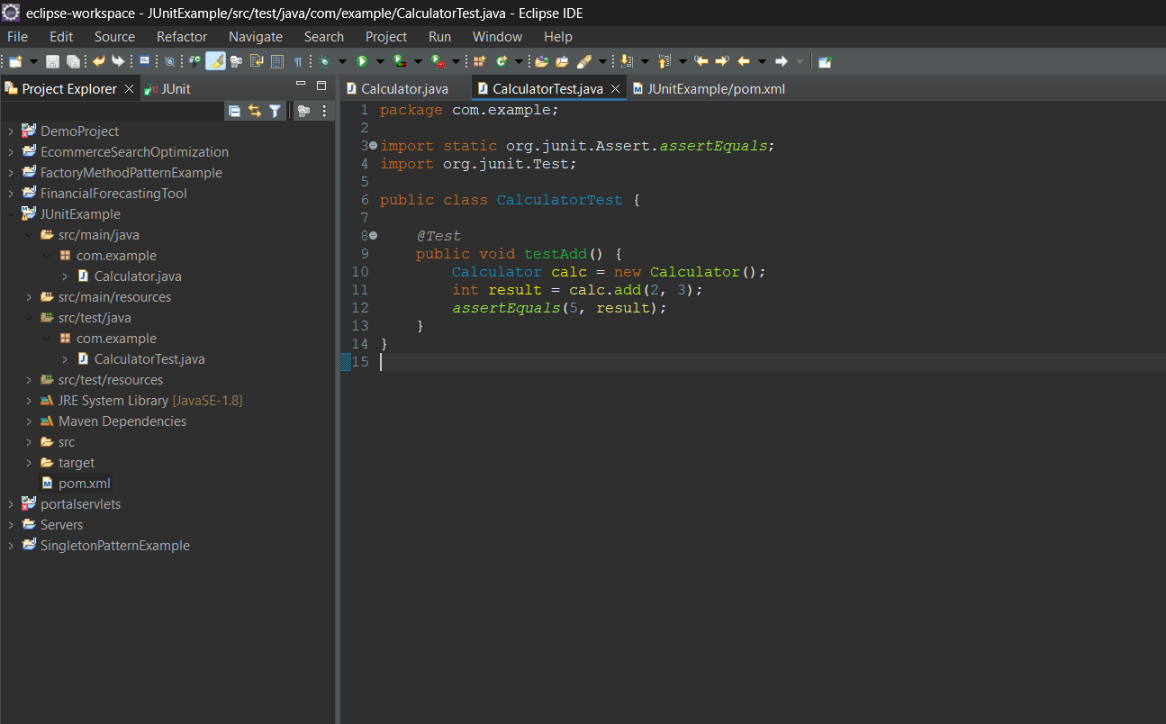

**Output:**

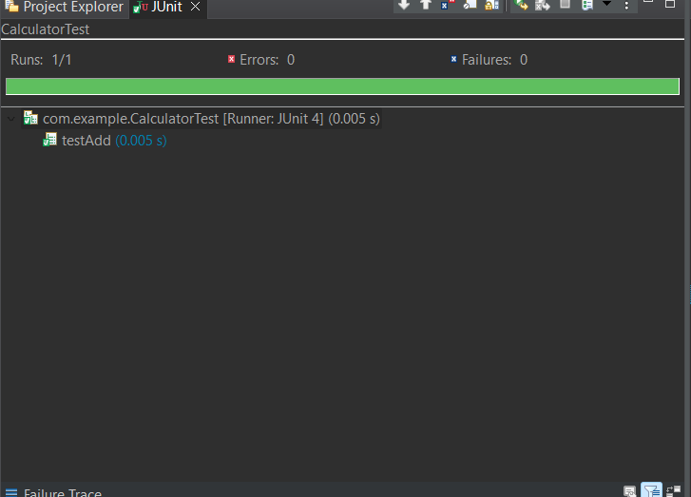

**EXERCISE 3: ASSERTIONS IN JUNIT**

**Pom.xml:**

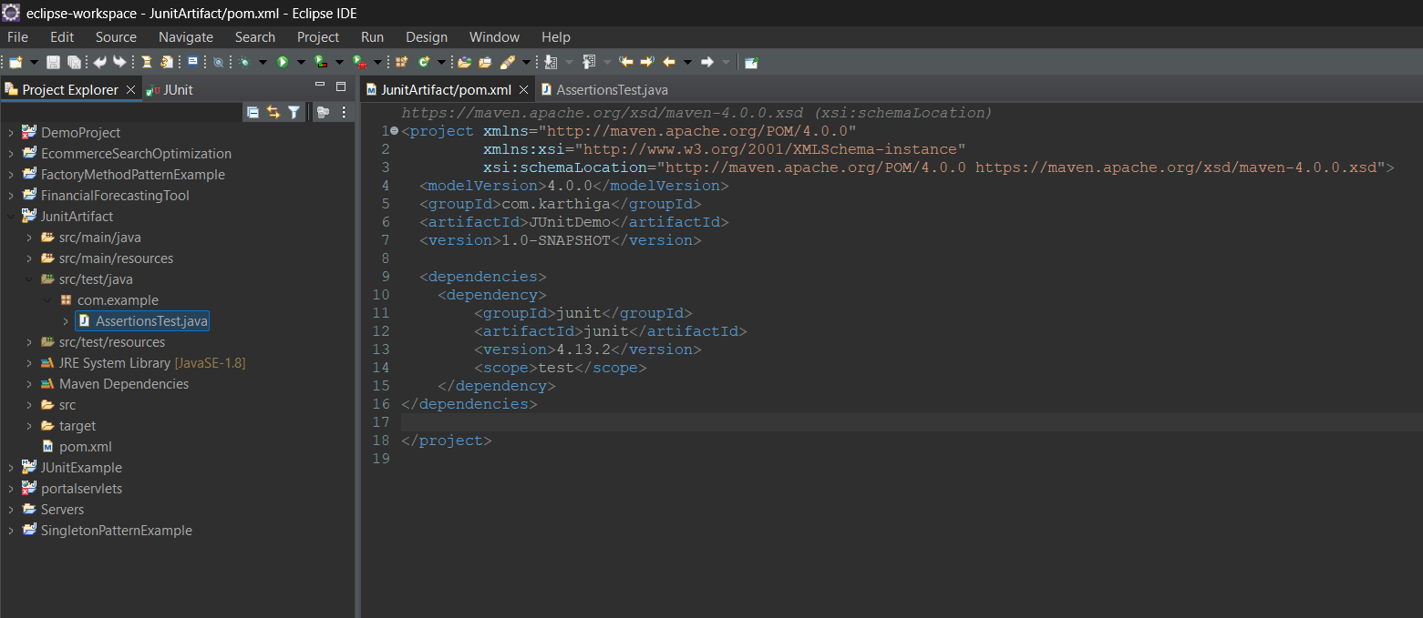

**AssertionsTest.java**

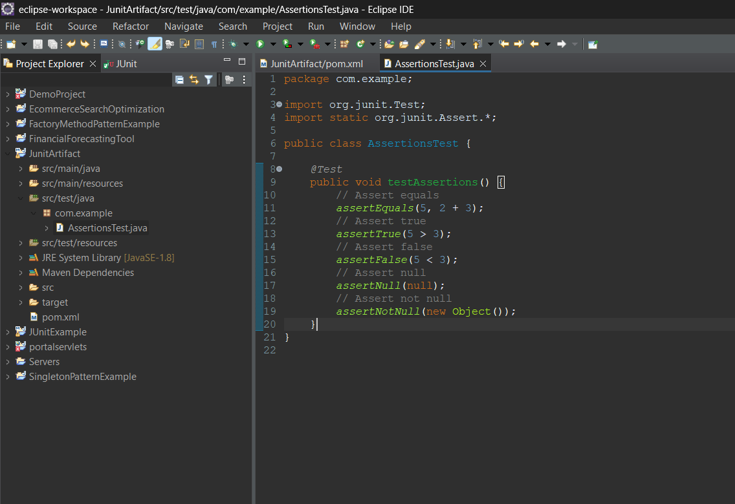

**Output:**

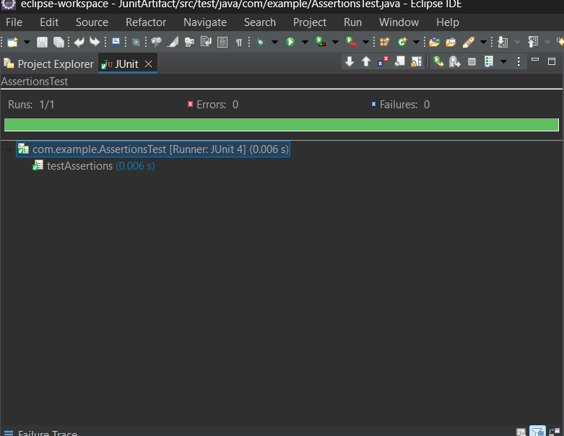

**EXERCISE 4: ARRANGE-ACT-ASSERT (AAA) PATTERN, TEST FIXTURES, SETUP AND TEARDOWN METHODS IN JUNIT**

**Pom.xml:**

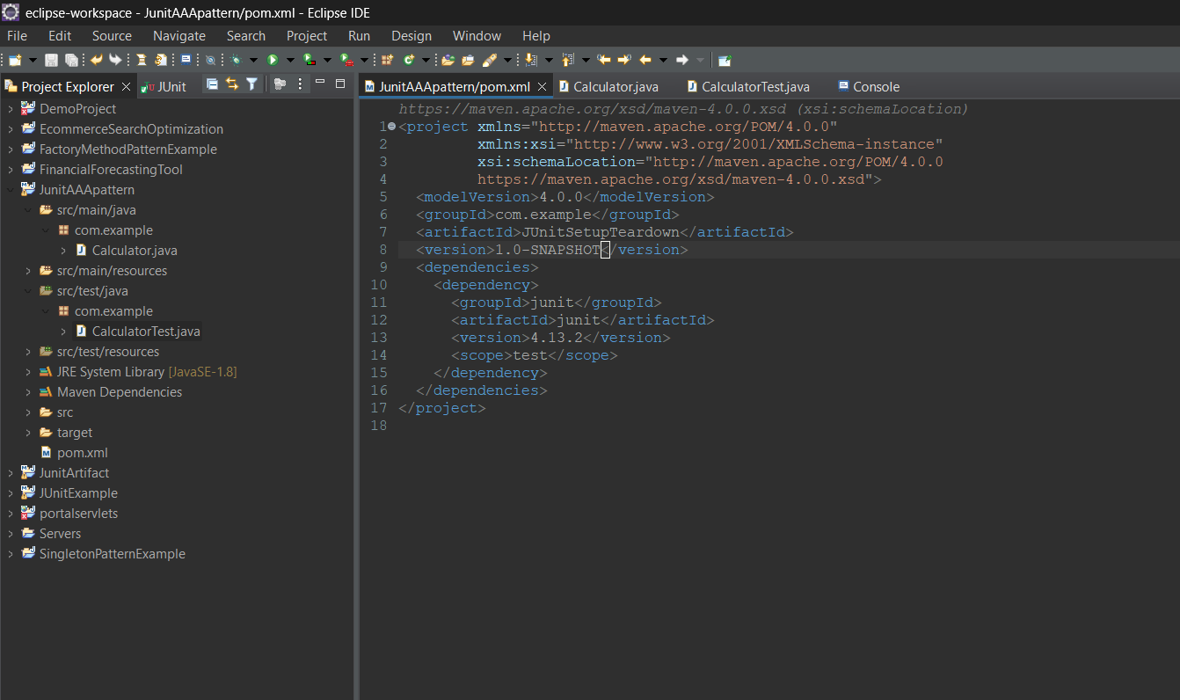

**Calculator.java:**

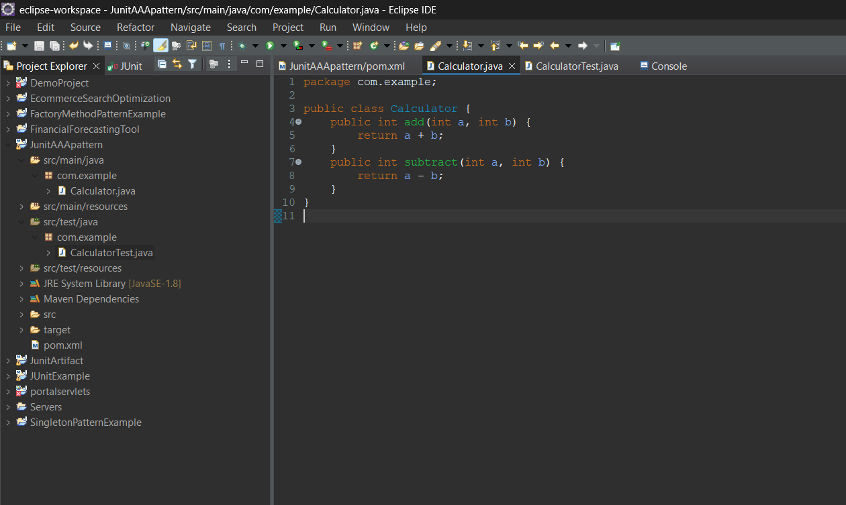

**CalculatorTest.java:**

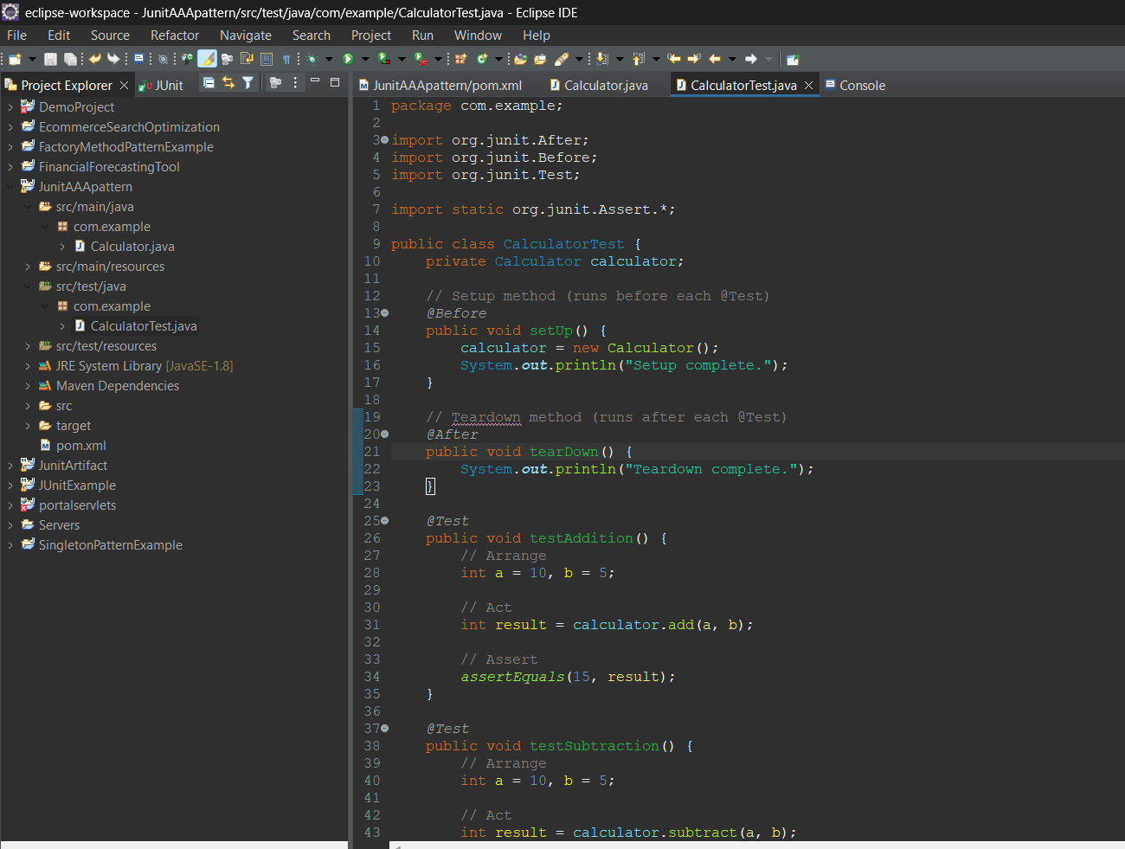

**Console:**

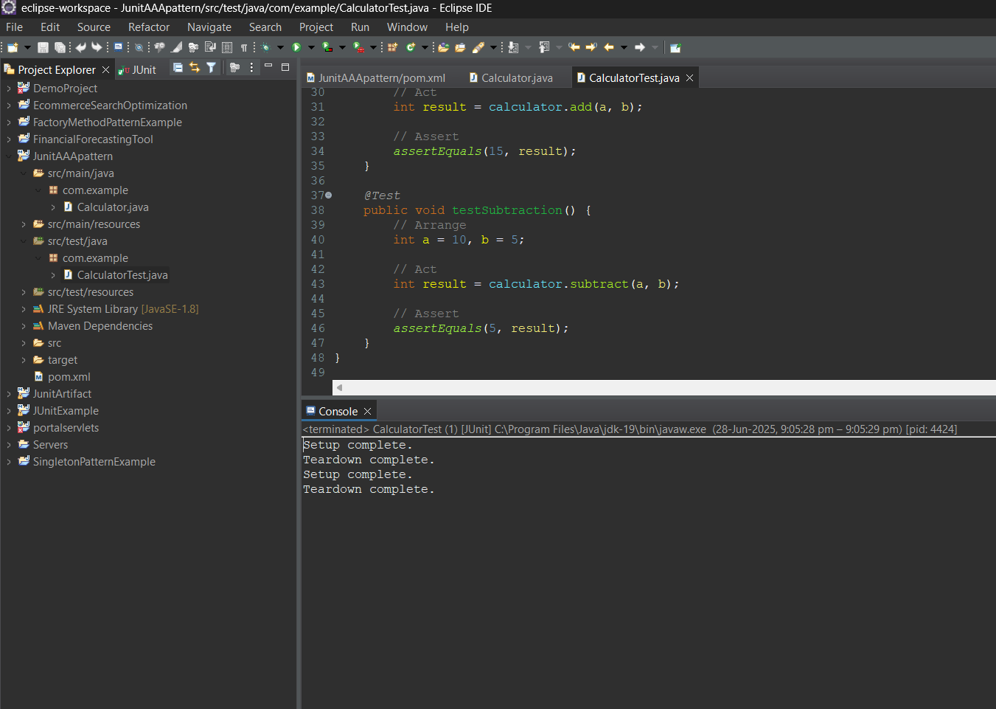

**Output:**

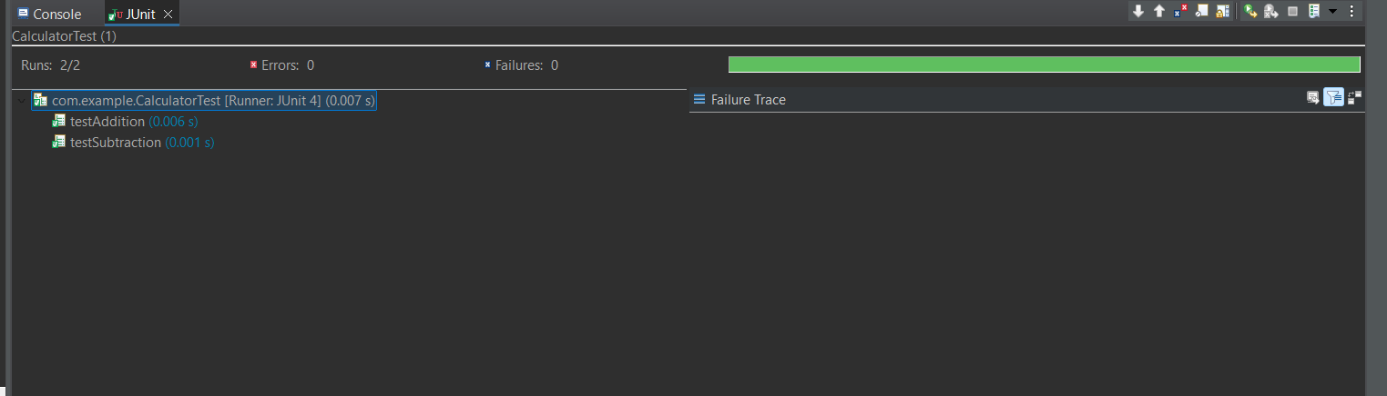

**MOCKITO EXERCISES**

**EXERCISE 1: MOCKING AND STUBBING**

**Pom.xml:**

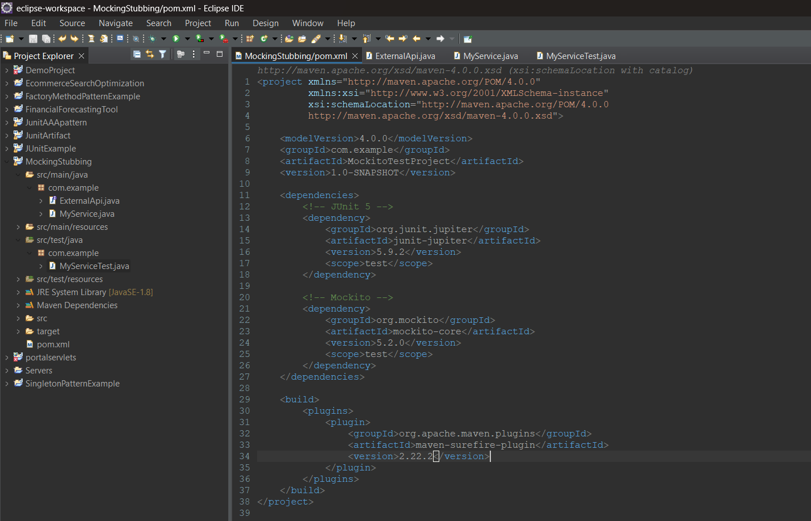

**ExternalApi.java:**

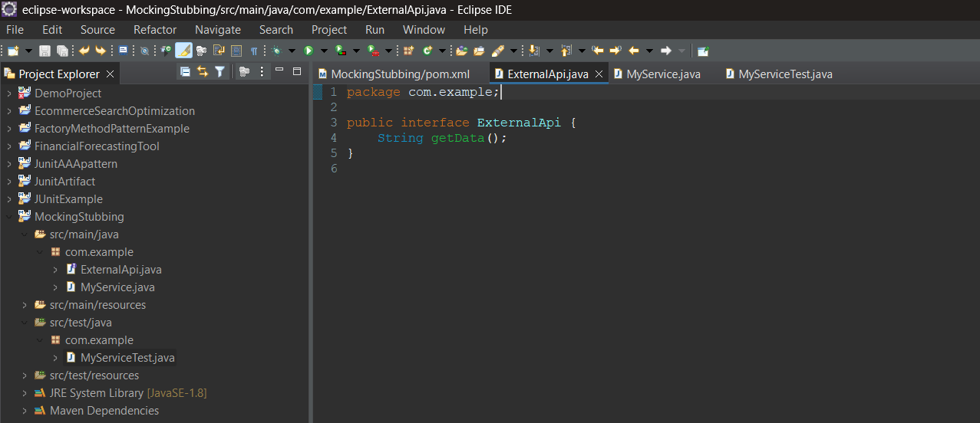

**MyService.java:**

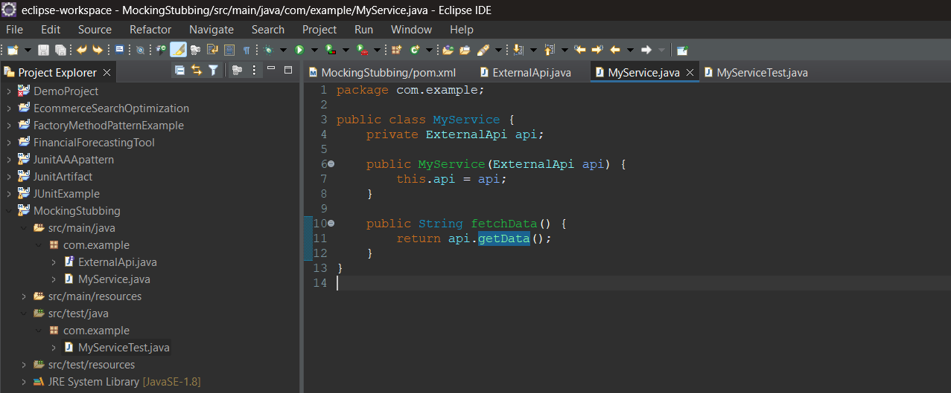

**MyServiceTest.java:**

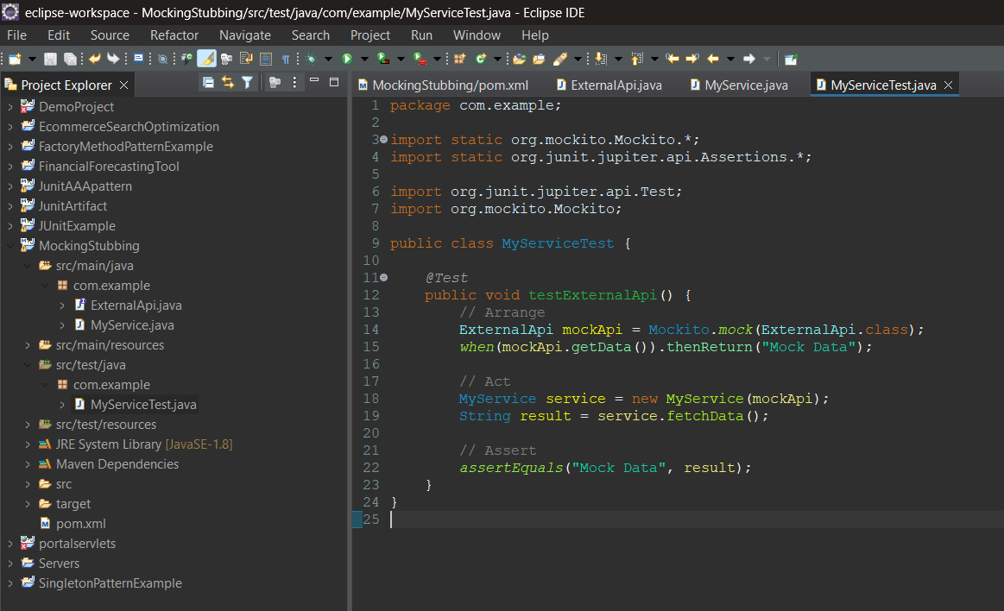

**Output:**

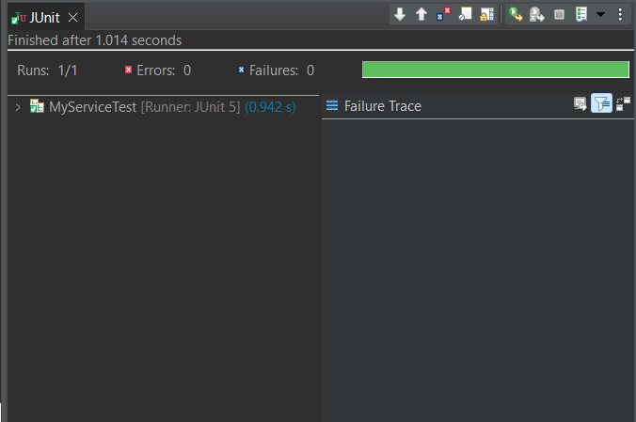

**EXERCISE 2: VERIFYING INTERACTIONS**

**Pom.xml:**

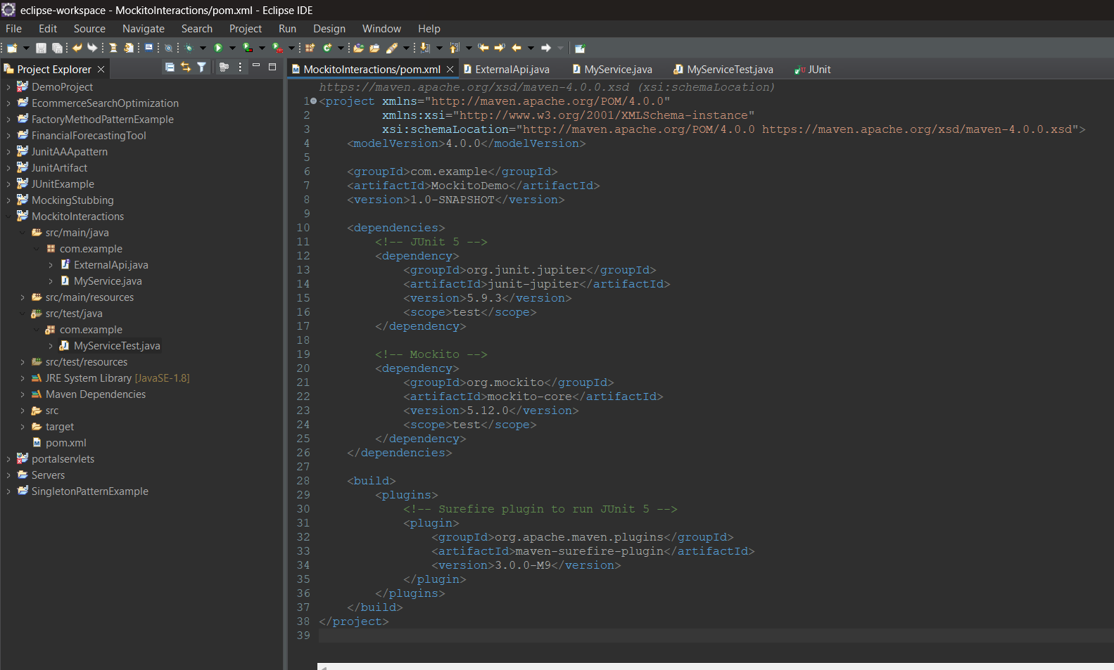

**ExternalApi.java:**

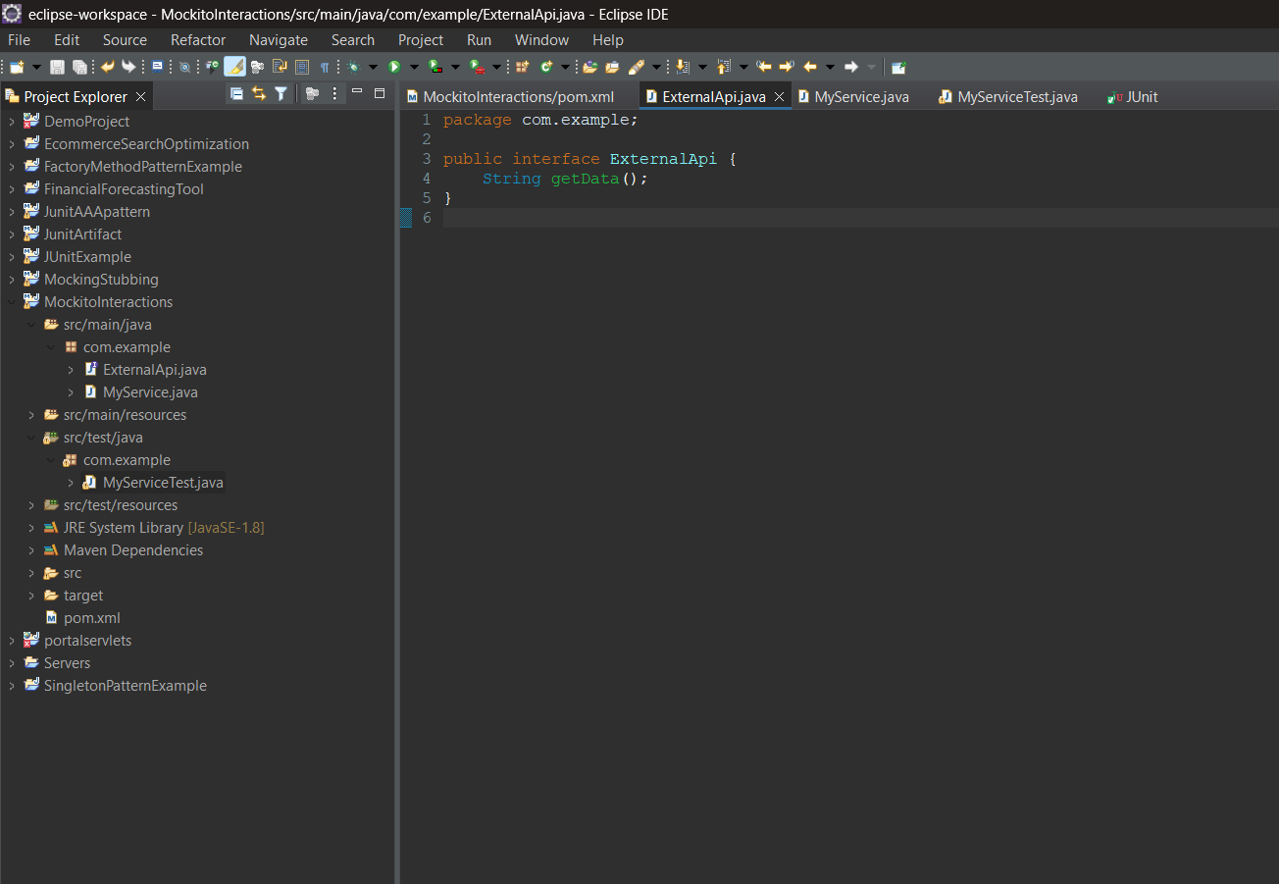

**MyService.java:**

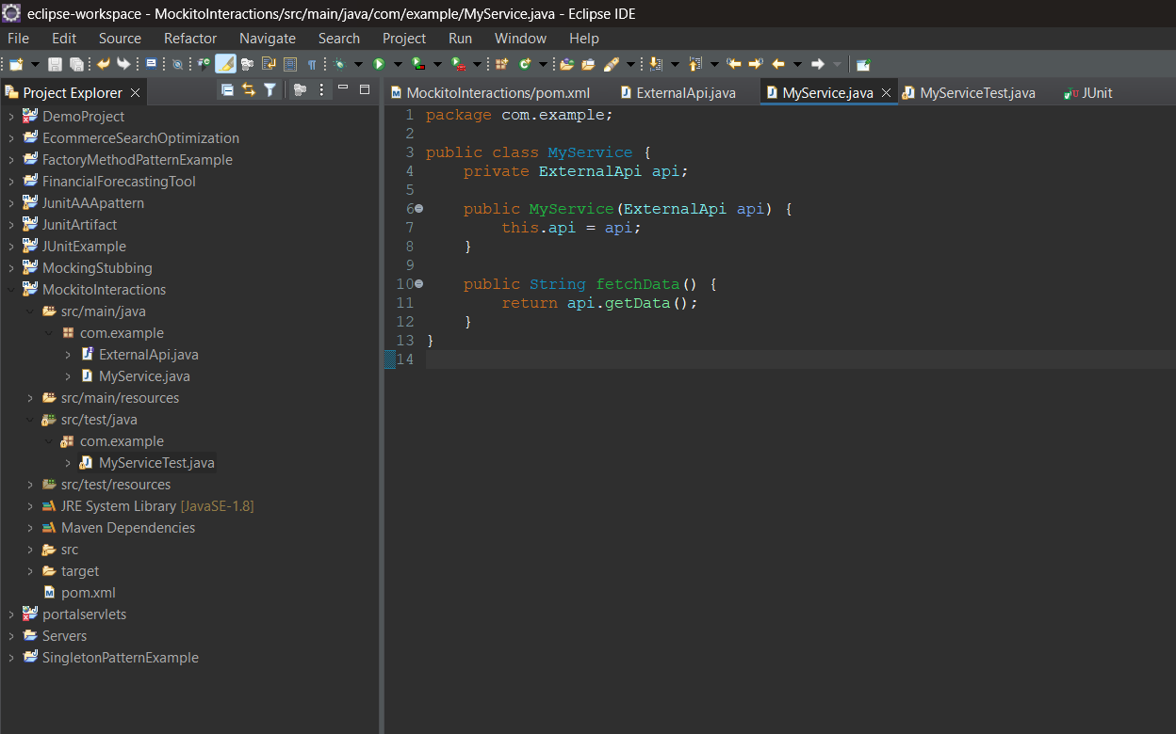

**MyServiceTest.java:**

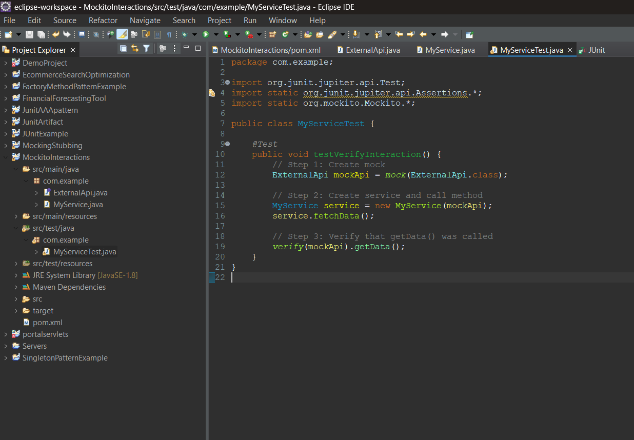

**Output:**

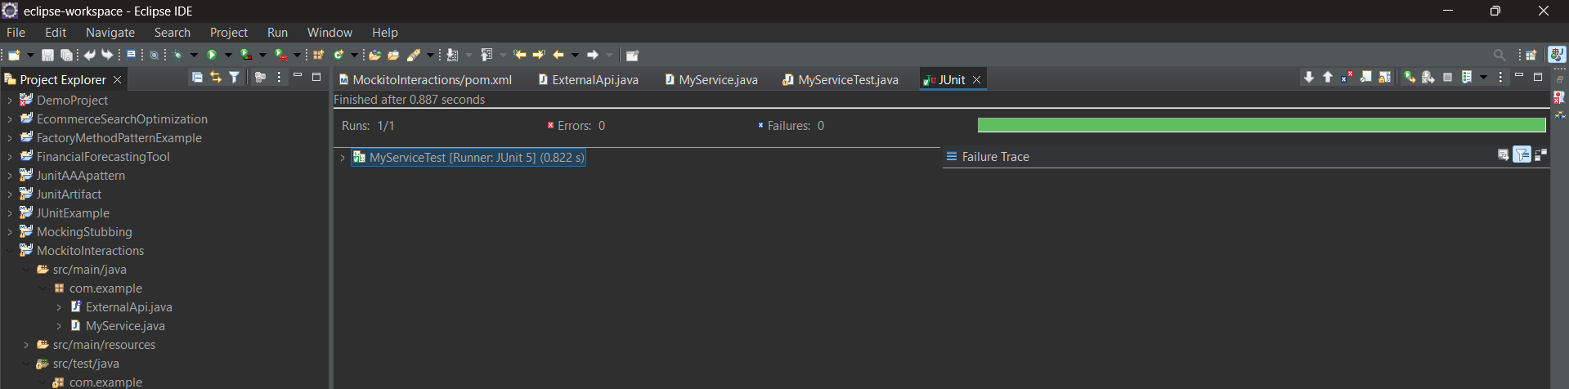

**SL4J LOGGING EXERCISES**

**EXERCISE 1: LOGGING ERROR MESSAGES AND WARNING LEVELS**

**Pom.xml:**

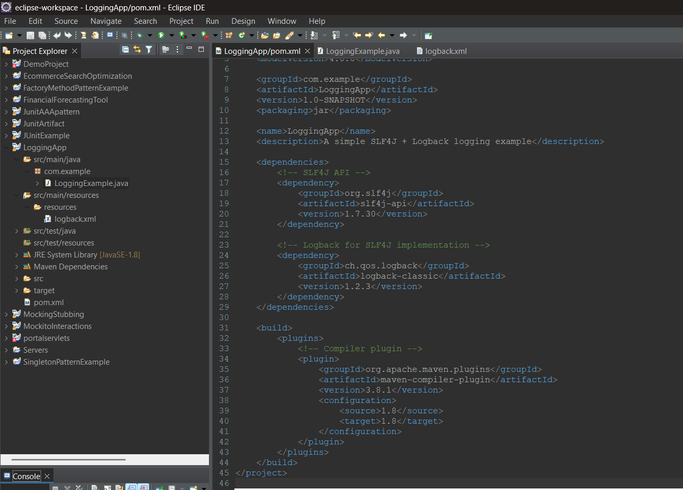

**LoggingExample.java:**

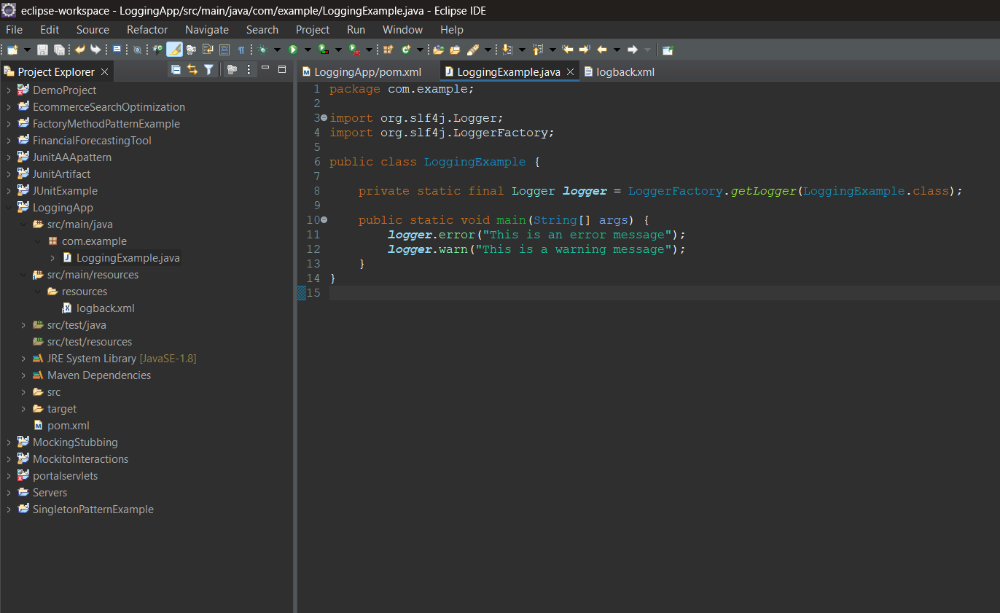

**Logback.xml:**

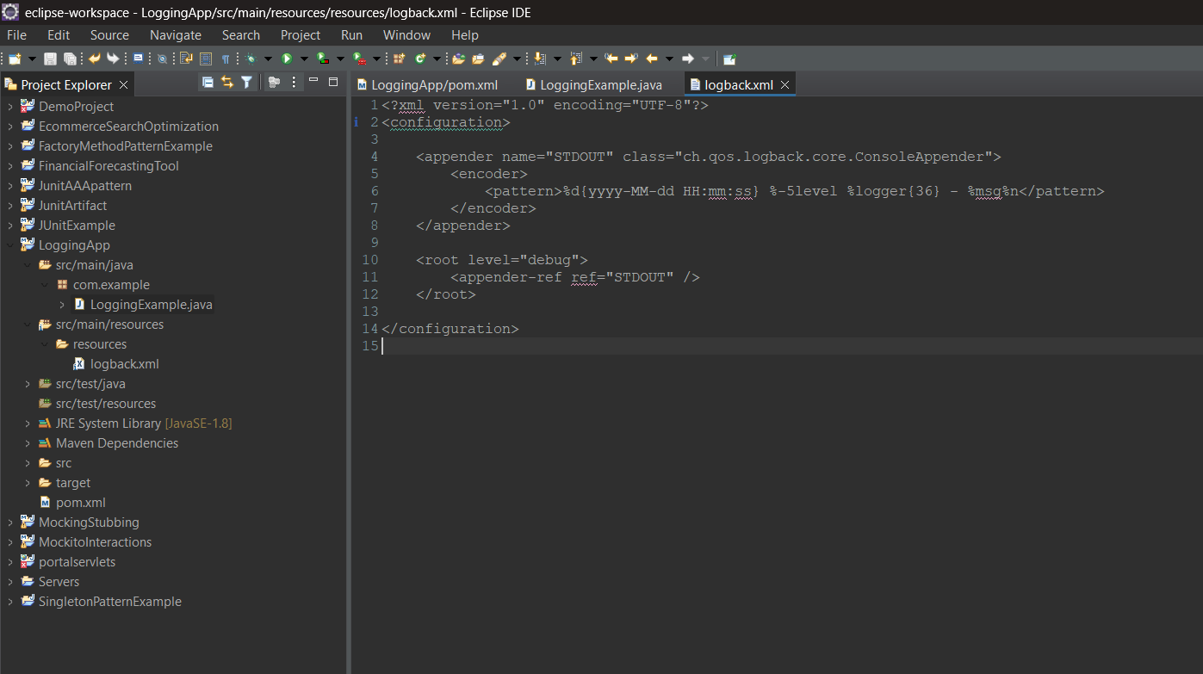

**Output:**

